External Users: L360 Login Process Update - Auth0 SMS MFA

We are pleased to announce that the L360 Multifactor Authentication (MFA) process for External Users has been simplified. We are eliminating the native Equus Assignment Pro MFA process (MFA code via e-mail or Authenticator), and providing External Users with an upgraded solution by integrating L360 with Auth0 MFA via SMS.
*External Users no longer need a code from an Authenticator app or e-mail each time that they log in*
L360 with Auth0 MFA via SMS allows for the 6 digit MFA code to be sent to an External User’s personal device via SMS text message. The user will need to input their phone number when prompted and all MFA codes will be sent to that phone number via SMS going forward. Standard text rates with your carrier will apply.
Please follow the below walkthrough if further assistance is required.
Other questions? See our “FAQs for L360” Document:
https://devlexicondocapist01.blob.core.windows.net/l360-docs/L360FAQ5.19.docx

- Enter your User ID, Password, and complete the Captcha. Click [Log In].
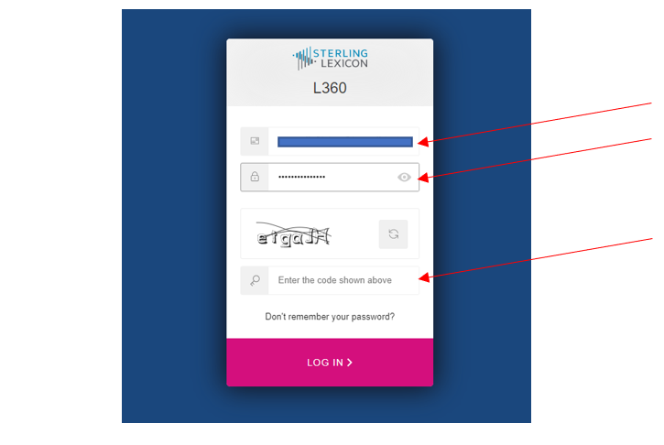
If you’re a new user or had your password reset, the following orange prompt will appear. Please follow the instructions to set your personal password.
If you are not a new user or have recently had your password reset, please continue to the next step.
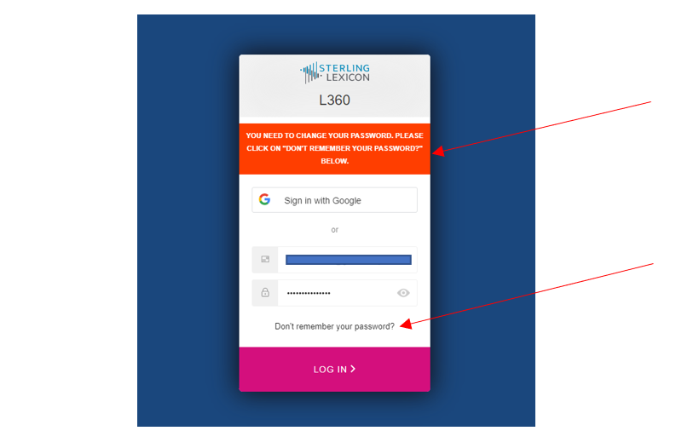

- Enter your phone number. This is where your 6 digit MFA code with be sent. Be certain that the device linked to your phone number has SMS (text messaging) capability. Once entered, click [Continue].

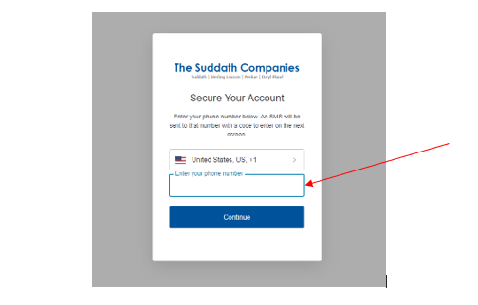

- Enter your 6 digit MFA code. Look to your device linked to the phone number that you entered. Enter the 6 digit code and click [Continue].

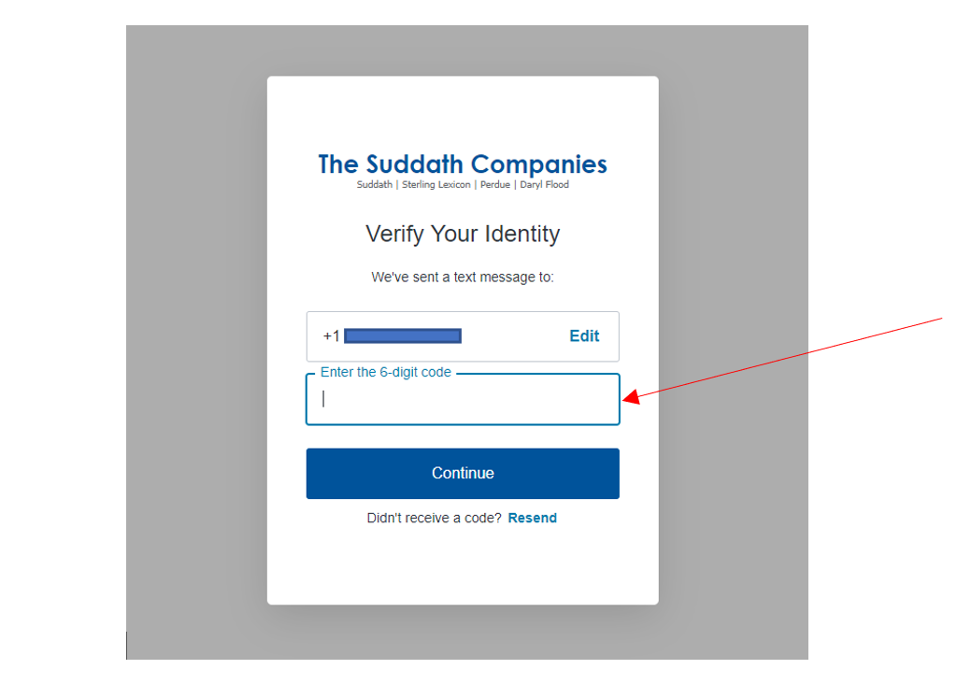

- Record this code for situations when you do not have access to your personal device on which you receive the MFA code.
*If you do not save this code and need to change your phone number, please contact your SL contact and they will initiate the process to reset your MFA info for a new number entry*

Click the box next to, “I have safely recorded this code,” and then [Continue].
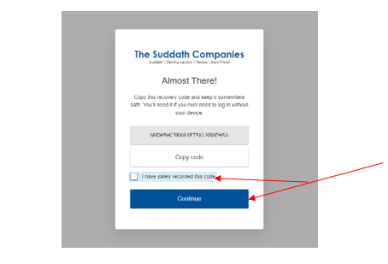

- You will see that your authorization is successful and your access has been granted.
*If you see anything else and are denied access, please provide a screenshot to your SL contact and they will investigate further*

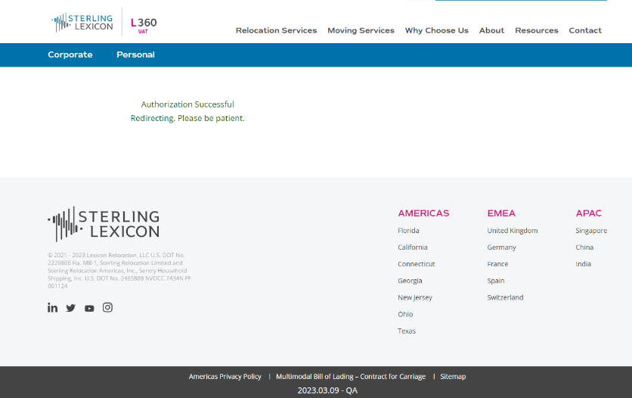

After a few seconds, you will be redirected to your L360 Landing Page.

The process is complete!





